Lab 02: Arithmetic and Data Movement in Assembly

Objective:
- Understand how to use registers for arithmetic operations.
- Learn the MOV, ADD, SUB, INC, DEC, and XCHG instructions.
- Observe results in registers.
Introduction:
In this lab, students will explore fundamental arithmetic and data movement operations in 8086 assembly language. The lab focuses on using CPU registers to perform basic computations such as addition, subtraction, increment, and decrement, as well as exchanging and transferring data between registers and memory. By practicing with instructions like MOV, ADD, SUB, INC, DEC, DIV, MUL and XCHG, students will gain a practical understanding of how the processor manipulates data, how results are stored in registers, and how memory interactions are handled in low-level programming. This foundational knowledge is essential for effective assembly programming and for understanding the inner workings of a CPU.
Moving data between registers
MOV AX, 5
MOV BX, 10
MOV CX, AX ; Copy AX to CX
Output:
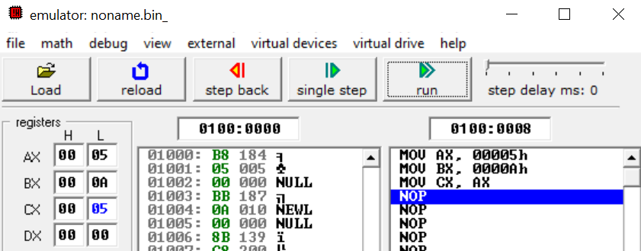

Exchanging Data between registers
MOV AX, 8
MOV BX, 4
XCHG AX,BX ; Exchange the data
HLT ; Stop CPU

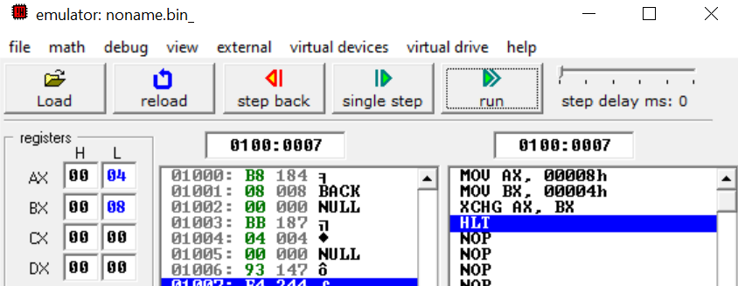
Basic Arithmetic Operations
Addition and Subtraction
ADD AX,3
SUB AX,1

Output:
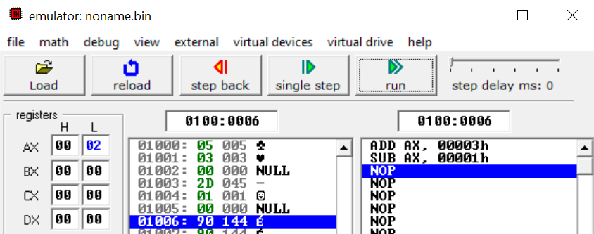

Increment and Decrement
ADD DX,3
INC DX
INC DX
DEC DX

Output
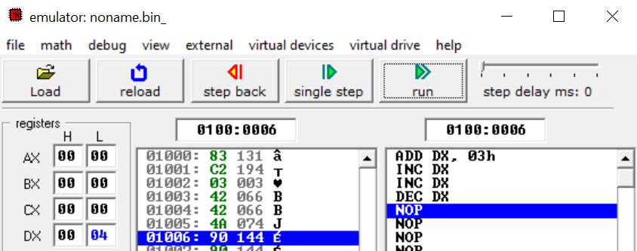

Multiplication in 8086 Assembly
In the 8086 microprocessor, multiplication is performed using the MUL (unsigned multiply) and IMUL (signed multiply) instructions. These instructions use the AX register implicitly as one of the operands, meaning the programmer does not need to specify it — the CPU assumes it automatically.
For 8-bit operands:
- The multiplicand is in AL (lower half of AX).
- The other operand is specified in the instruction.
- The result is stored in AX.
Example
MOV AL, 05h ; AL = 5
MOV BL, 04h ; BL = 4
MUL BL ; AX = AL × BL = 20h
HLT

Output
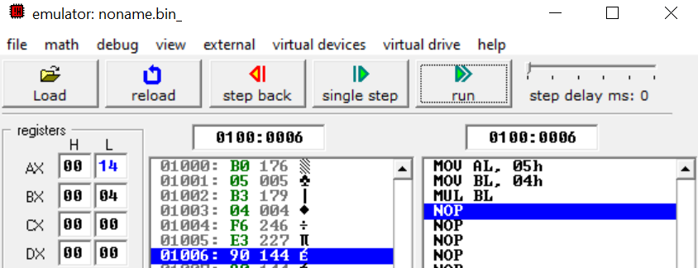
For 16-bit operands:
- The multiplicand is in AX.
- The other operand is specified in the instruction.
- The result is stored in DX:AX (DX = high word, AX = low word).
Example:
MOV AX, 500 ; AX = 500
MOV BX, 300 ; BX = 300
MUL BX ; DX:AX = AX × BX = 150000h
HLT

Output
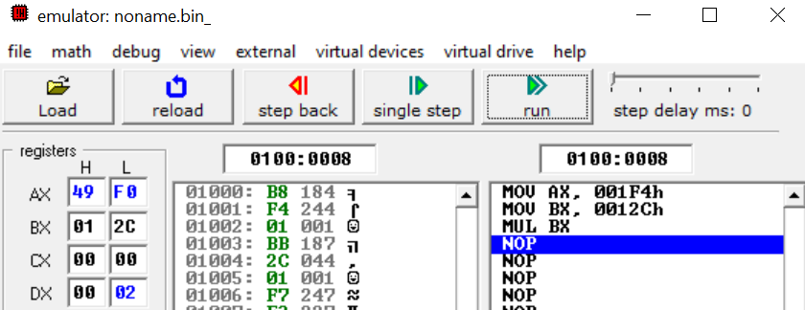
32-bit register in 8086: On the 8086, each register is 16-bit, but sometimes you need to hold results larger than 16 bits (like after multiplication or before division). For that:
- AX + DX are paired together → called DX:AX.
- This makes a 32-bit register pair (DX is the high 16 bits, AX is the low 16 bits).
Interpretation for above result: Result = 150000 (decimal) = 0x249F0 (hex) → needs more than 16 bits.
- AX = 46F0h (low word)
- DX = 0002h (high word)
- Together: DX:AX = 0002 46F0h = 150000 decimal.
Division (Same as multiplication)
MOV AX, 20 ; Dividend
MOV BX, 4 ; Divisor
DIV BX ; AX / BX → quotient in AX, remainder in DX
HLT ; Stop CPU
Output:
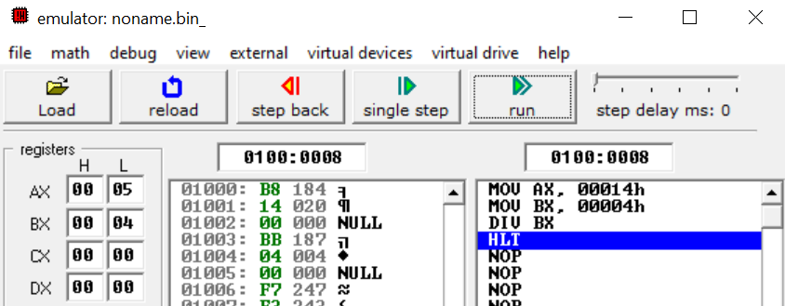

Dealing with negative numbers
Using 8-bit Register
MOV AL, -4
HLT

Output:
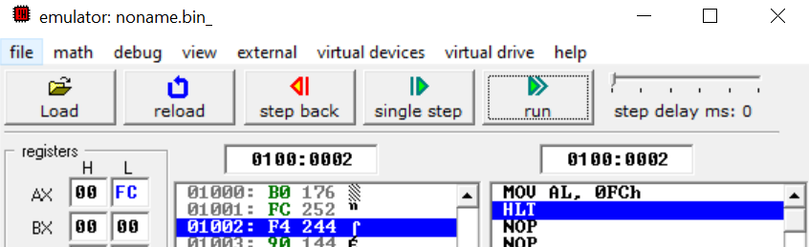
For 8-bit representation of -4 using two’s complement:
- Start with +4 in 8-bit binary: 0000 0100
- Take 1’s complement (invert all bits): 1111 1011
- Add 1 to get 2’s complement: 1111 1100
- Convert to hexadecimal: 1111 1100 → FC
So, -4 in 8-bit hexadecimal is FC.
Similarly:
- 16-bit: FFFC
- 32-bit: FFFFFFFC
Using 16 Bit Register
MOV AX,-4
HLT

Output:
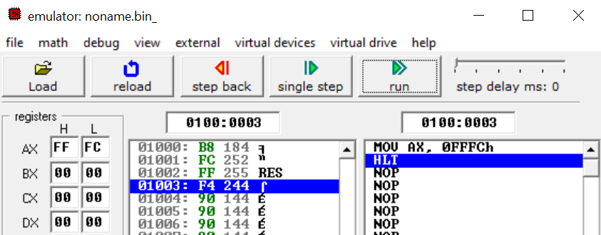
Exercise:
Task 1: Explore IMUL and IDIV operations and use them in example to distinguish them with MUL and DIV operations respectively.
Task 2: Perform any DIV operation using 32 bits (DX:AX).
Task 3: Use MUL and IMUL with positive numbers, and compare results.
Task 4: Use DIV and IDIV with positive numbers, and compare results.

